  SNIR | Basic video worksheet  Computer Networking tutorial |   ESLA

Watch the video and answer the following questions:
- What is the router (ˈraʊtə) connected to?

The router is connected to the modem.

- What are the two types of routers? What’s the difference of setting up? What’s the difference of use?

Wireless routers with Wi-Fi connection.
Wired routers with cabled connection.

- What is the role of a router?

To distribute connection and give the best way to connect the routes.

- Reproduce the diagram representing the Home Network
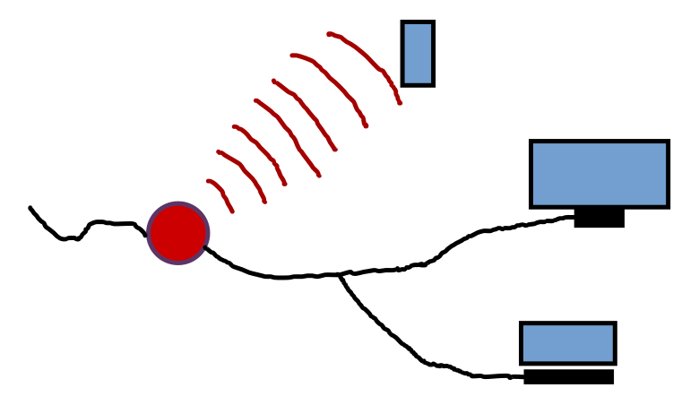

- Bonus question: Is a router enough to have access to the Internet? Explain.

It must be connected to the external network.

